April 17, 2025

To Growers, Pest Control Businesses, and Pesticide Dealers:
Interstate Ag Plastics will be in Imperial County to recycle empty, triple-rinsed pesticide containers beginning Monday, April 28, 2025. They will be in the east parking lot of the Imperial Valley Expo (fairgrounds). You may contact Interstate Ag Plastics at (661) 764-9614 if you have questions regarding hours of operation or the status of your materials.
Important recycling procedures:
- Bring containers in a conspicuously marked trailer (name and phone no.) that can be left at the facility and quickly moved. Interstate Ag Plastics requests that trailers have a door or gate to access the trailer.
- Do not park your trailer outside of the east parking lot. If the gate is closed, you must return during regular hours of operation. Call Interstate Ag Plastics for hours of operation and be aware that the fairgrounds may have gates open on the north or south side of the facility, but not necessarily both. Please share this information with your staff, as trailers are routinely left in prohibited areas, such as driveways or surrounding streets.
- Trailers must be covered (lid, tarp, etc.) to keep containers from blowing out of the trailer. High winds are common and often remove paper signs and tarps when not adequately secured, so please affix all identification and tarps securely.
- Containers must be triple-rinsed, clean, and in good condition. No dirt or pesticide residue on containers will be accepted. Containers that are old and brittle will also not be accepted.
- Caps and labels must be removed.
- Get a receipt from Interstate Ag Plastics. This receipt can verify the appropriate handling and disposal of empty pesticide containers. Burning or burying containers is not a proper disposal method.
- Interstate Ag Plastics will only stay until there are no more materials to be recycled. All trailers must be removed from the Imperial Valley Expo parking lot before May 15, 2025.
This is a free service. Please take advantage of the opportunity. If you have any questions, please call Sam Gretencord or me at (442)265-1500.

Sincerely,
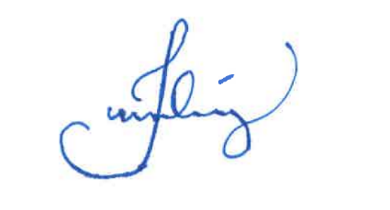
Julian D. Lopez
Deputy Agricultural Commissioner
Pesticide Use Enforcement

